Table of Contents

1.1 Accessing PIE 2

1.2 Basic Navigation 2

1.3 Home Page 2

1.4 About Page 3

1.5 Help Page 4

1.6 Registration 5

1.7 Logging In 6

1.8 Navigating Your Profile 6

1.9 Viewing Profiles 7

2.0 Events 9

2.1 Connections 10

2.2 Notifications 11

2.3 Photos 12

2.4 Signing Out 15

### Table of Figures

Figure 1.1 Basic Navigation 2

Figure 2.1 About Page 3

Figure 3.1 Help Page 4

Figure 4.1 Registration 5

Figure 5.1 Login Page 6

Figure 6.1 Profile Page 6

Figure 7.1 Profile Page With Events 8

Figure 8.1 Schedule an Event 9

Figure 9.1 Events 9

Figure 10.1 Searching Connections 9

Figure 11.1 Users 9

Figure 12.1 Viewing Notifications 10

Figure 13.1 Editing Images 11

Figure 14.1 Uploading Profile Photos 12

Figure 15.1 Removing Profile Photos 13

Figure 16.1 Selecting Profile Photos 14

Figure 17.1 Signing Out 15

### Accessing PIE

Personal Interactive Experiences can be accessed on any device with a browser by visiting <http://pie.navhost.com>. Tested browsers include Chrome, Internet Explorer, Firefox, Safari, and Opera. The website is meant for personal computers and laptops, but can also be accessed on mobile devices. To visit the site, locate the address bar at the top of your browser and enter "pie.navhost.com". Hit "Enter" to begin loading the site.

### 1.2 Basic Navigation

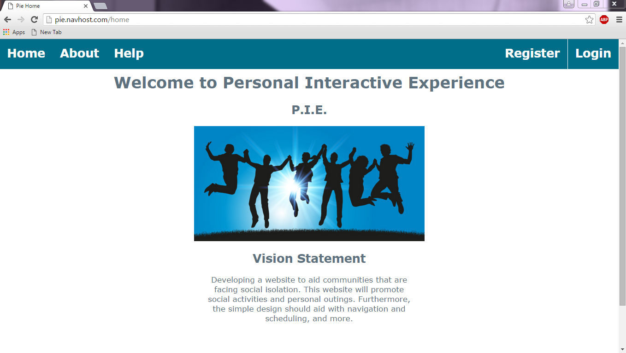

Figure 1.1 Basic Navigation

The navigation bar can be found at the top of the page. Tabs include "Home", "About", "Help", "Register", and "Log In". When you hover your cursor over these tabs, they will highlight, allowing you to see which page you will be accessing. Simply click the tab you want to view and you will be redirected to the corresponding page. The "Home" page is open by default. There is also a footer found on every page of the site. The footer contains some information about our site. It also includes two hyperlinks: an "About" link that will send you to our "About" page and a "Contact" link that will send you to our "Help" page.

### 1.3 Home Page

The "Home" page can be accessed by clicking the "Home" tab from anywhere on the site. When you are logged out, this page displays the name of the site and a small section explaining our site's vision statement. When you are logged in, this tab will redirect you to your profile page.

### 1.4 About Page

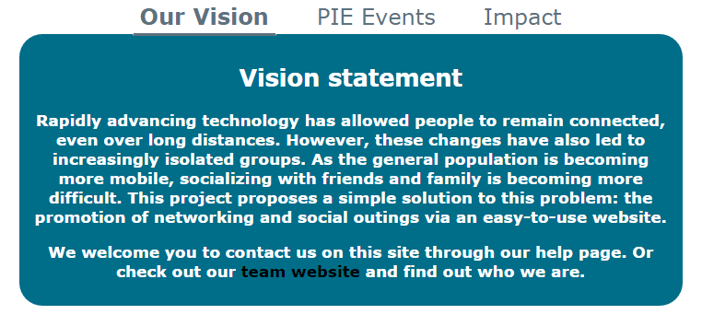

Figure 2.1 About Page

The "About" page can be accessed by clicking the "About" tab from anywhere on the site. The "About" page explains our site's vision statement, explains how events work, and gives information on the impact that the site has had on different communities. These three topics can be found by clicking their corresponding tabs located beneath the picture (Our Vision, PIE Events, and Impact). The "Our Vision" tab is opened by default. The "PIE Events" and "Impact" tabs can be accessed by clicking their respective tabs. The current tab is indicated by bold underlined text. Hyperlinks can be found in the body of the tabs. These links are colored black and regular text is colored white. The hyperlink located under the "Our Vision" tab will open our team's website. The hyperlink under the "Events" tab will open a picture of a sample event and give an explanation of what each of the fields contain. While viewing the sample event, you can navigate to any of the pages with the navigation bar or go back to the "About" page by pressing the button labeled "Back".

### 1.5 Help Page

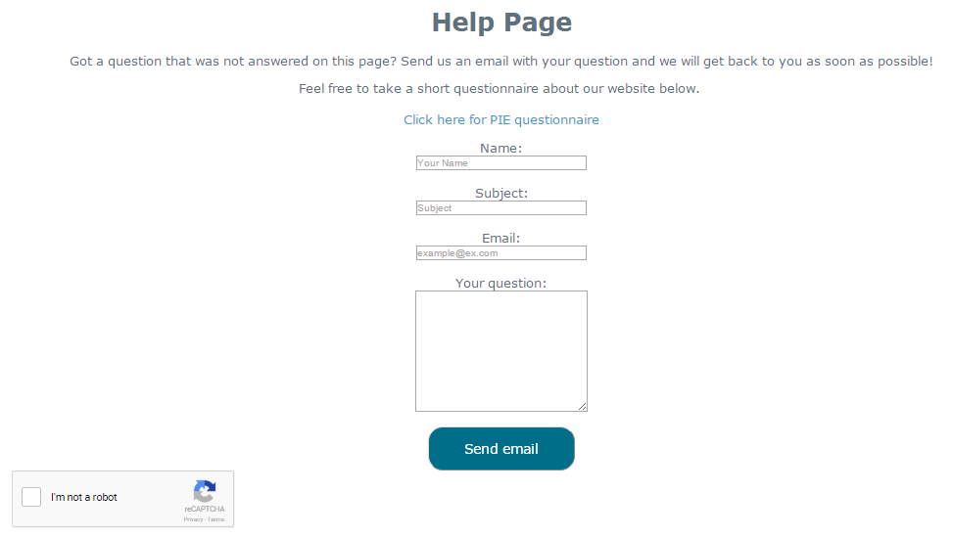

Figure 3.1 Help Page

The "Help" page can be accessed by clicking the "Help" tab from anywhere on the site. It can also be accessed by clicking the "Contact" button on the footer. When you are logged in, you can also navigate to the "Help" page by clicking "Help" on the sidebar located on the left hand of your profile page.

The "Help" page allows you to email our group and gives the option to fill out a survey about our site. To contact us for help, use the textbox labeled "Name" to enter your name. Use the text box labeled "Subject" type in a subject, or a brief explanation of your question or comment. Use the text box labeled "E-mail" to type in your e-mail (Ex. Your-email@gmail.com). Use the text area labeled "Your question" to type in your question or comment. When you are done filling out these fields, you are required to click the box labeled "I'm not a robot" and answer any confirmation questions to ensure that you are a human user. When these fields are filled, click the "Submit" button located below the "Your question" text area to send an e-mail to our group. When more questions are answered, we will add Frequently Asked Questions (FAQs) to this page.

To fill out a survey, click the link labeled "Click here for PIE questionnaire". This will redirect you to a page that will allow you to fill out a survey created by our group for testing purposes.

### 1.6 Registration

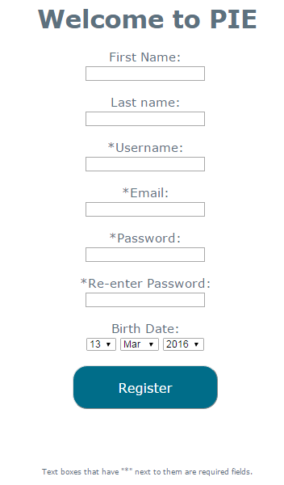

Figure 4.1 Registration

You can create a profile on our site by clicking the tab labeled "Register" located near the top-right corner of the page. This tab can be seen on any page as long as you are not currently logged in. The registration page requires a "Username", a "Password", and an "E-mail" address in order to create an account. You may also fill out the fields labeled "First Name", "Last Name", and "Birth Date", but they are not required. Required fields are denoted by an asterisk (*) next to their descriptions. When you have filled out your information, click the "Register" button to create an account. Upon registration, you will be redirected to your profile page.

### 1.7 Logging In

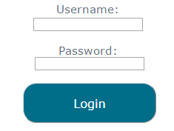

Figure 5.1 Login Page

As explained in "Registration", you can log in by registering a profile. If you have previously created a profile, you can click the "Login" tab located near the top-right corner of the page. Type your username in the textbox labeled "Username" and type your password in the textbox labeled "Password". After these fields are entered, click the button labeled "Login" to log in to your profile.

### 1.8 Navigating Your Profile

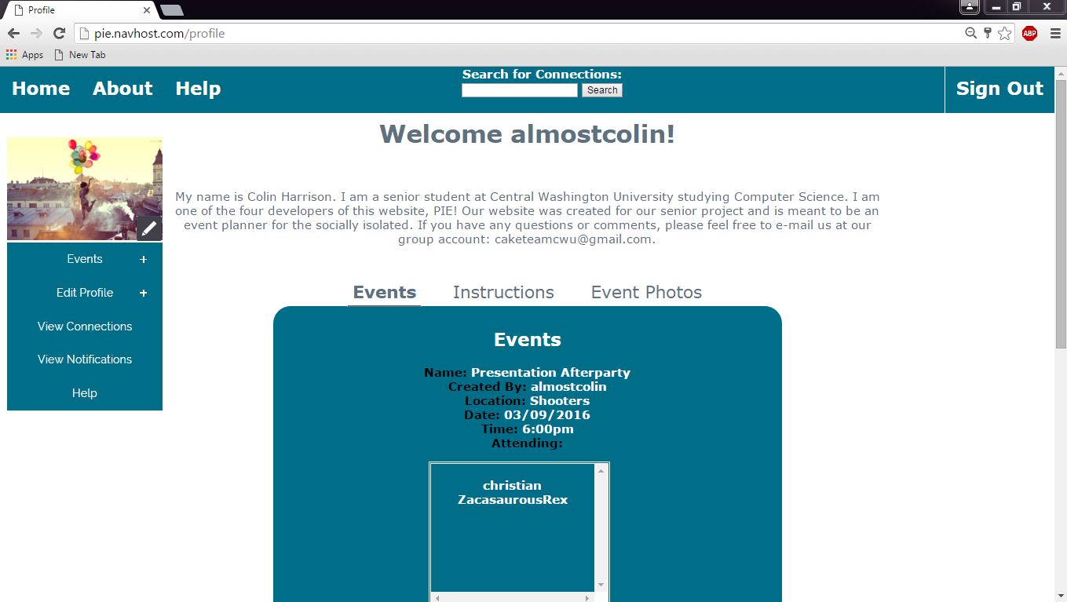

Figure 6.1 Profile Page

To add an event, click the "Events" button found on the left sidebar. Select "Create Event" and fill in the form data. When you create an event, you will be able to view the details about that event as well as other events you will be attending in the "View All Events" button found under "Events" on the sidebar. The "View All Events" allows you to edit or delete events after their creation. Your events are also displayed under the "Events" tab on your profile page.

To add or remove a photo, click on the "Edit Profile" button found on the left sidebar and select "Edit Photos". You can also manage photos by clicking on the "Edit icon" found on the bottom-right of your current profile picture.

To edit your profile's description, click on the "Edit Profile" button found on the left sidebar and select "Edit Description". Fill in the text area labeled "Description" and click the "Add Description" button to submit your description.

To find connections, or friends, search for the connection's username using the text area and search button located in the center of the header (found on the top of the page). While viewing a user's profile, you can add them as a connection with the "Add Contact" button found on the top-right of the page (beneath the "Sign Out" button). If you have already added that user, you will not see the "Add Contact" button. You can view your connections by clicking "View Connections" button found on the sidebar on the left side of the page.

You can view your notifications by clicking "View Notifications" on the left side of the page. The notifications page displays information concerning connection invites and event invites.

If you have any questions or comments concerning the site, use the "Help" button found on the sidebar on the left side of the page. Fill out the form to send an e-mail to the site's developers.

### 1.9 Viewing Profiles

To find connections, or friends, search for the connection's username using the text area and search button located in the center of the header (found on the top of the page).

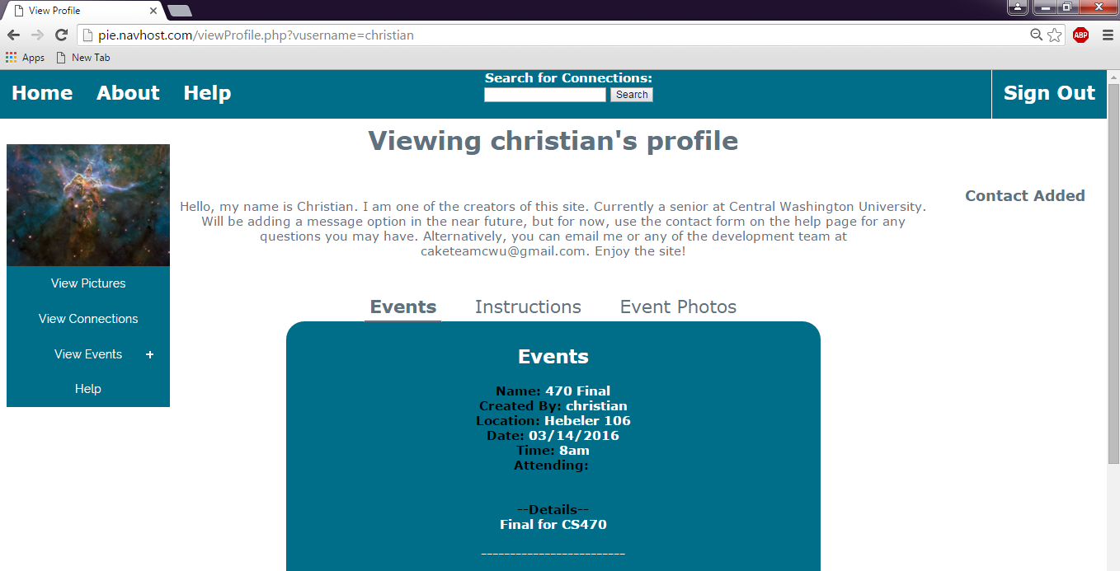

Figure 7.1 Profile Page With Events

To get back to your profile page, click the "Home" button located in the top-left corner of the page. If a user is in your connections, you can view all of their profile pictures, their connections, and their events. All of these options can be found on the sidebar on the left side of the page.

To add the viewed user to your connections, click the "Add Contact" button found on the top-right of this page (below the "Sign Out" button). More options will be allowed if a user is added to your connections.

If you have any questions, comments, or concerns, do not hesitate to e-mail our project team by using one of the "Help" buttons, which can be found on the top-left of the page (Next to "About") or on the bottom of the sidebar on the left side of the page.

### 2.0 Events

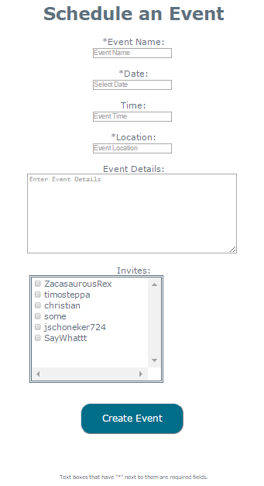

Figure 8.1 Schedule an Event

You can create an event by clicking "Events" then "Create Event" on the left sidebar under your profile picture. The fields for Event Name, Date, and Location are required. You can also enter a time and details about your event under the "Time" textbox and "Event Details" text area. The box under "Invites" displays all of your connections. Click the checkbox next to their name to invite them to your event. Submit your event by clicking the button labeled "Create Event". This will send a notification to all of the connections that you invited and post your event under your "Events" tab on your profile page.

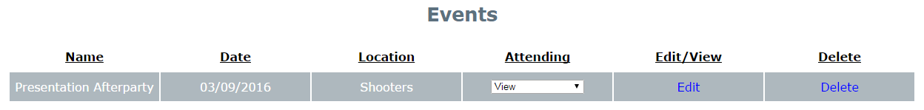

Figure 9.1 Events

You can view and edit your events by clicking "Events" then "View All Events" on the left sidebar under your profile picture. This page displays all of your events in a table format. The table will show your event's "Name", the event "Date", the "Location" of the event, and the "Attending" connections. Attending connections can be viewed by clicking the dropdown box under the "Attending" column. You can View and edit your event by clicking the "Edit" link under the "Edit/View" column. You can delete your event by clicking the "Delete" link under the "Delete" column.

### 2.1 Connections



Figure 10.1 Searching Connections

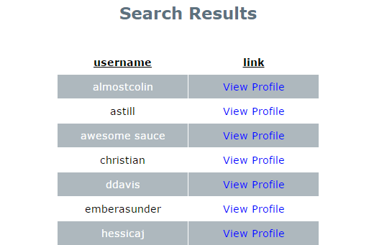

Figure 11.1 Users

To find connections, or friends, search for the connection's username using the text area and search button located in the center of the header (found on the top of the page). Usernames of different users will be displayed in a table based on your search. The table has two columns: "username" shows the usernames of the users and "link" gives you a link labeled "View Profile" that allows you to view user profiles. While viewing a user's profile, you can add them as a connection with the "Add Contact" button found on the top-right of the page (beneath the "Sign Out" button). If you have already added that user, you will see "Contact Added" displayed in place of the "Add Contact" button. You can view your connections by clicking "View Connections" button found on the sidebar on the left side of the page.

The "View Connections" button will take you to a page where your connections are displayed in a table. The table includes the connection's username under the column labeled "Contact Username". You can view the connection's profile by clicking the "View Profile" link under the column labeled "View Profile". You can remove the contact by clicking the "Delete" link located under the column labeled "Remove Contact".

### 2.2 Notifications

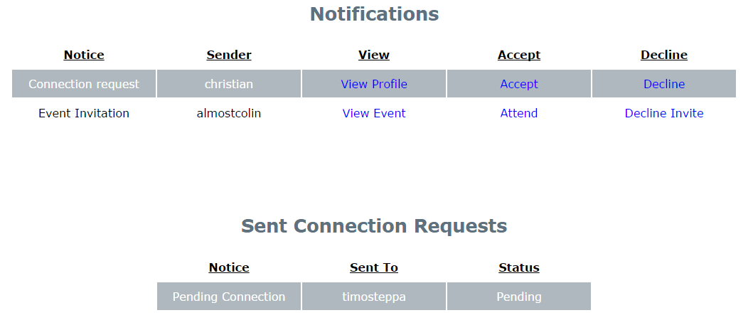

Figure 12.1 Viewing Notifications

You can view your notifications by clicking "View Notifications" on the left side of the page. The notifications page displays information concerning connection invites and event invites.

Connection requests and event invitations are displayed in the table located under the "Notifications" header. This table includes a "Notice" column that displays the type of notification (Ex. Connection Request or Event Invite). The "Sender" column shows the username of the sender of the request. The "View" column allows you to view the profile of the request's sender by clicking the link labeled "View Profile". The "Accept" column allows you to accept the event or connection invitation by clicking the link labeled "Accept". The "Decline" column allows you to decline the event or connection invitation by clicking the link labeled "Decline".

Connection requests that you sent are displayed in a table under the "Sent Connection Requests" header. The "Notice" column of this table displays the type of notification (Ex. Pending Connection). The "Sent To" column shows the username of the person that the request was sent to. The "Status" column shows the status of the request (Ex. Pending).

### 2.3 Photos

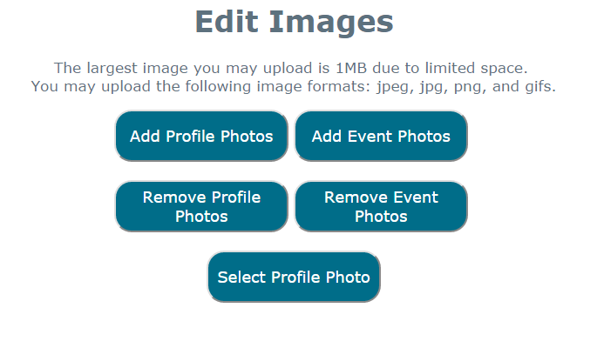

Figure 13.1 Editing Images

If you have not selected a profile photo, your current profile photo will be defaulted to a "blank user" image. To add or remove a photo, click on the "Edit Profile" button found on the left sidebar and select "Edit Photos". You can also manage photos by clicking on the "Edit icon" found on the bottom-right of your current profile picture.

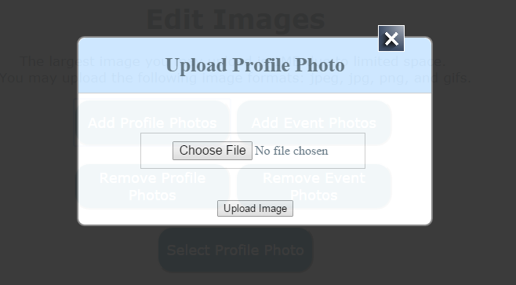

Figure 14.1 Uploading Profile Photos

To add a profile photo, click the button labeled "Add Profile Photos". To add an event photo, click the button labeled "Add Event Photos". These buttons will bring up a pop up form. Use the button labeled "Choose File", use the opened directory to navigate to your image's location, then either double click your image, or click the image and press "Open". Your currently selected image's name will then be displayed next to the "Choose File" button. After you have selected an image, click the "Upload Image" button to submit your image.

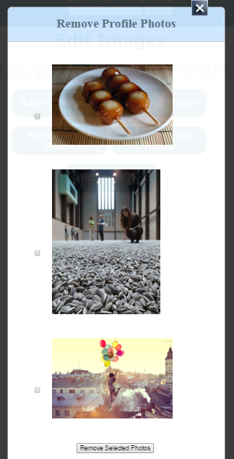

Figure 15.1 Removing Profile Photos

To remove a photo, click the "Remove Profile Photos" or "Remove Event Photos" button depending on which type of photo you would like to remove. Your photos will be displayed in a pop up form with a checkbox next to each image. Click the checkbox next to each image that you want to remove. After you have checked each image you want to remove, click the button labeled "Remove Selected Photos" located at the bottom of the pop up form.

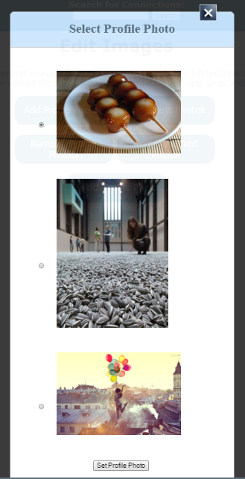

Figure 16.1 Selecting Profile Photos

To select your current profile photo, click the "Select Profile Photo" button. This button will bring up a pop up form that displays all of your profile photos with a radio button next to each photo. Click the radio button next to the photo that you would like to set as your profile photo. When you have selected your desired profile photo, click the button labeled "Set Profile Photo" located at the bottom of the pop up form. After selecting your profile photo you will be directed back to your profile page.

### 2.4 Signing Out



Figure 17.1 Signing Out

You can only sign out of your profile if you are currently logged in. To sign out of your profile, click the "Sign Out" button located at the top-right of any page that you are on. Upon signing out, you will be redirected to the logged-out "Home" page.